QES VDOT Processing Application Instructions

Page

* Initial Settings 1
  + Excel Settings 1
  + Access Settings 4
* Starting the Application 7
* Step-By-Step Processing 8
* What Happens When Reprocessing a District 17

**Initial Settings –**

Excel and Access need to have a few settings changed in order for VDOT Processing to work. The settings will need to be changed anytime you login to a new computer. Once set for your account on that computer, it will not need to be modified again.

***Excel Settings-***

**Step 1**: Open Excel with a new “Blank workbook”.

**Step 2**: Click on File and choose Options.

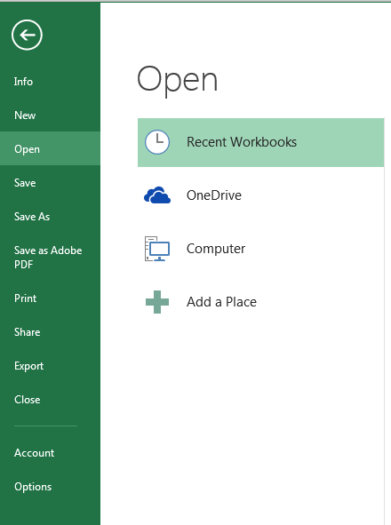

**Step 3**: Choose Trust Center from the menu on the left and click on “Trust Center Settings”.

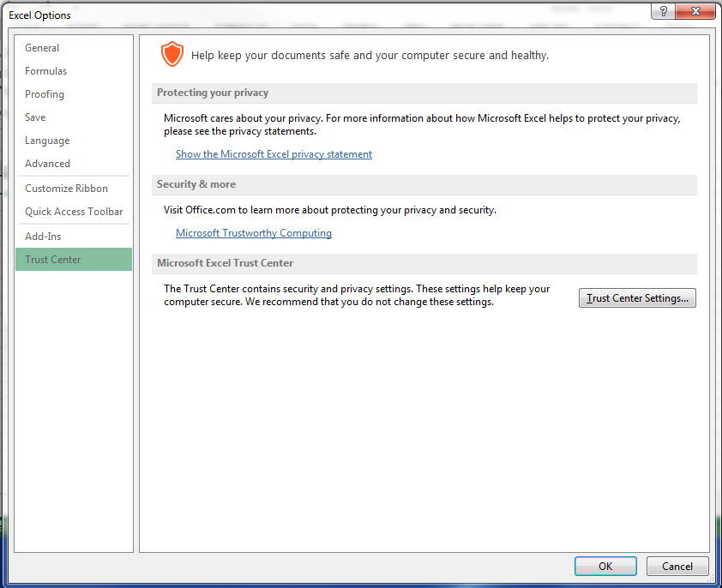

**Step 4**: Choose “Macro Settings” from the menu on the left. Make sure “VBA project object model” is enabled.

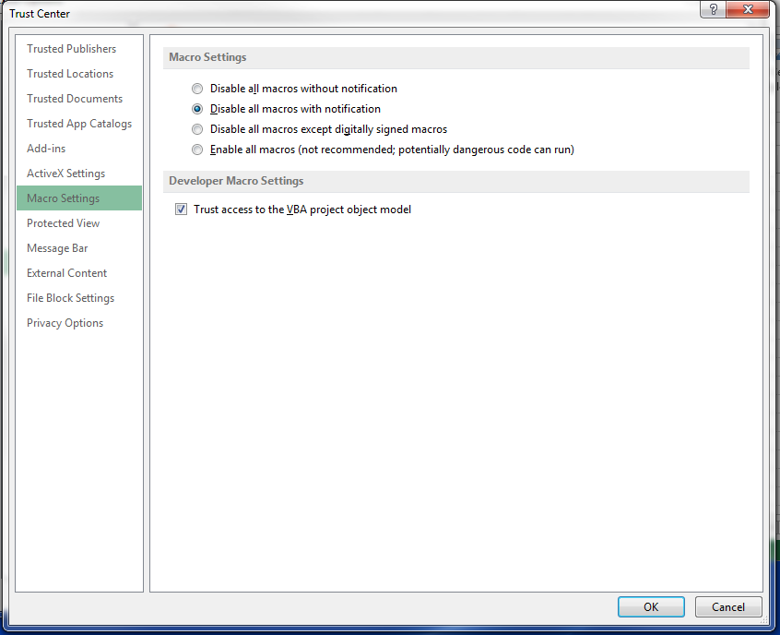

**Step 5**: Choose “Trusted Locations” from the left menu. Check if \\QES-RENO\Projects\ is in the list with subfolders enabled.

**Step 6**: If \\QES-RENO\Projects\ is not on the list, check “Allow Trusted Locations on my network” and click on “Add new location”.

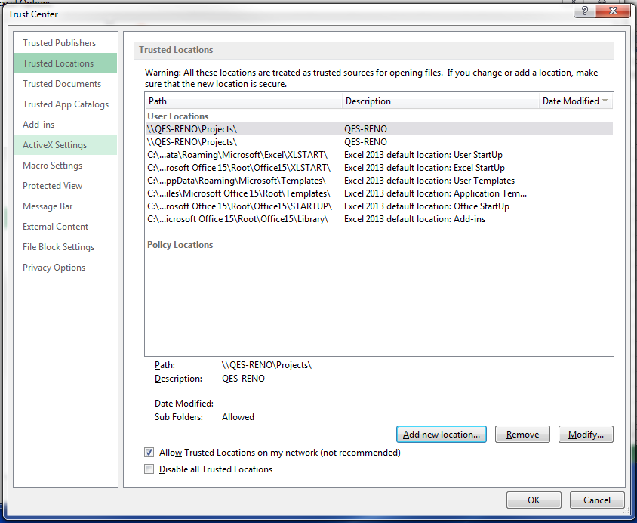

**Step 7**: Enter ” \\QES-RENO\Projects\ “ in the path box and check the box next to “Subfolders of this location are also trusted”. Click OK.

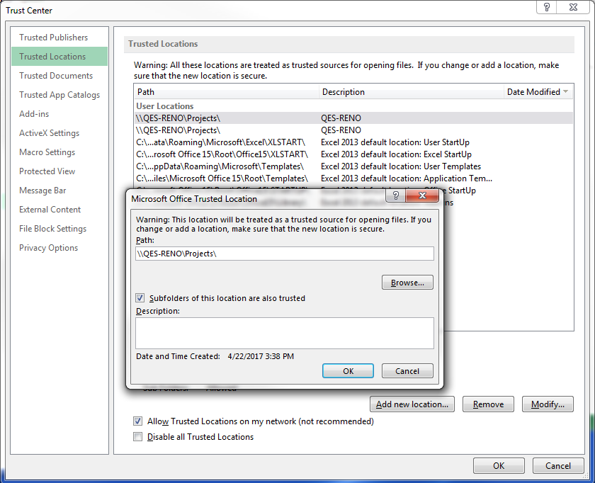

**Step 8**: Click OK on the Trust Center window.

**Step 9**: Click OK on the Excel Options window and close the document.

***Access Settings-***

**Step 1**: Open Access with a new database.

**Step 2**: Click on File and choose Options.

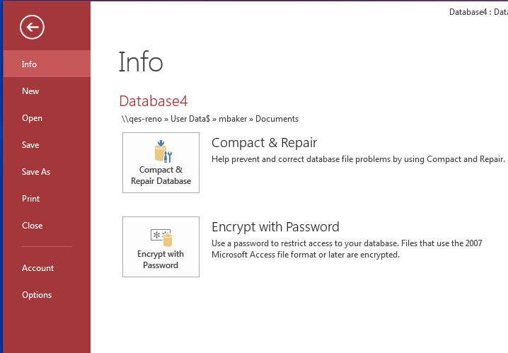

**Step 3**: Choose Trust Center from the menu on the left and click on “Trust Center Settings”.

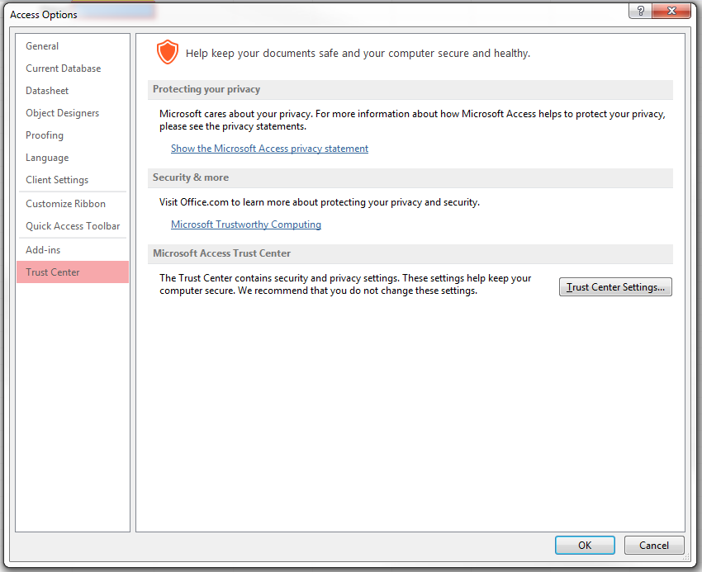

**Step 4**: Choose “Trusted Locations” from the left menu. Check if \\QES-RENO\Projects\ is in the list with subfolders enabled.

**Step 5**: If \\QES-RENO\Projects\ is not in the list, click on “Add new location”.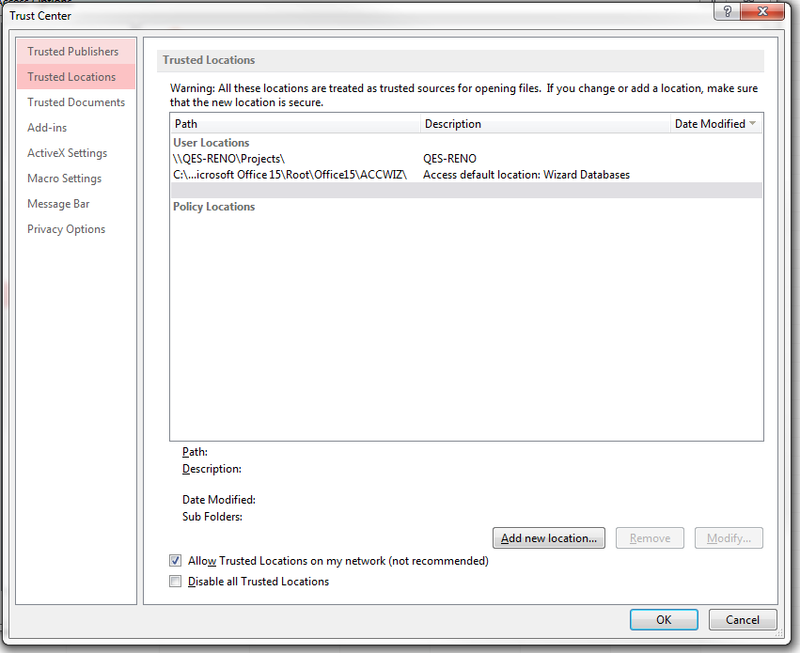

**Step 6**: Enter “ \\QES-RENO\Projects\ “ in the path box and check the box next to “Subfolders of this location are also trusted”. Click OK

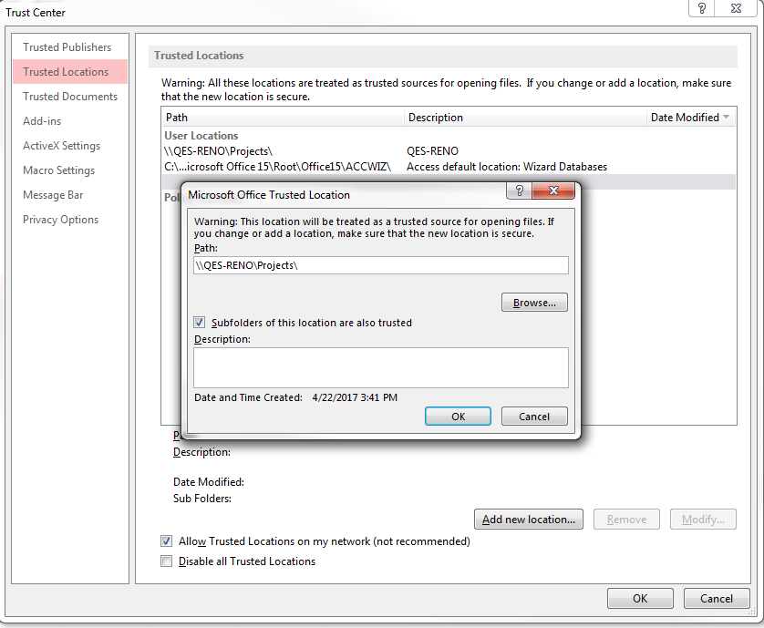

**Step 7**: Click OK on the Trust Center window.

**Step 8**: Click OK on the Access Options window and close Access.

**Starting Application** –

The databases used with this program might need to be opened first in order to enable content. Without enabling content in these databases, the program will fail. 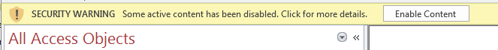

To start the VDOT Processing Program, navigate to \\QES-RENO\Projects\VDOT and choose “VDOT Processing” .

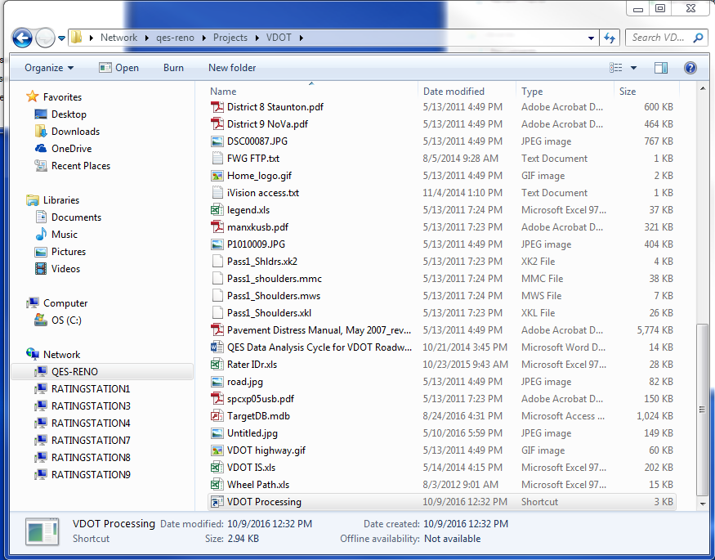

**STEP-BY-STEP Processing**

**STEP 1:** Enter the name of the new database you want to create. If you do not want to change the name, leave NewDatabase in the input box.

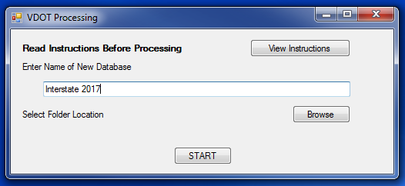

**STEP 2:** Once you decide on a name, click on the “Browse” button. 

**STEP 3:** A new window will open. Navigate through the folders and find the folder you want to place the new database. Click “OK” once you choose the folder. 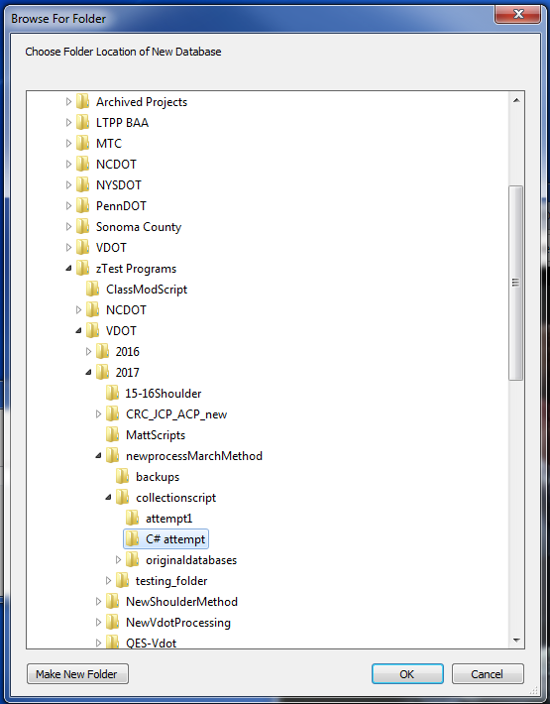

**STEP 4:** The folder location you chose is shown on the main screen. To start the processing click “START”.

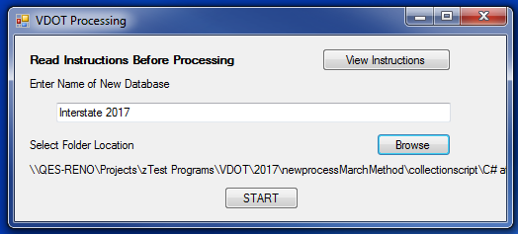

**STEP 5:** Access will open the new database and prompt you to select the sample file of the division you want to process. Click “OK”. 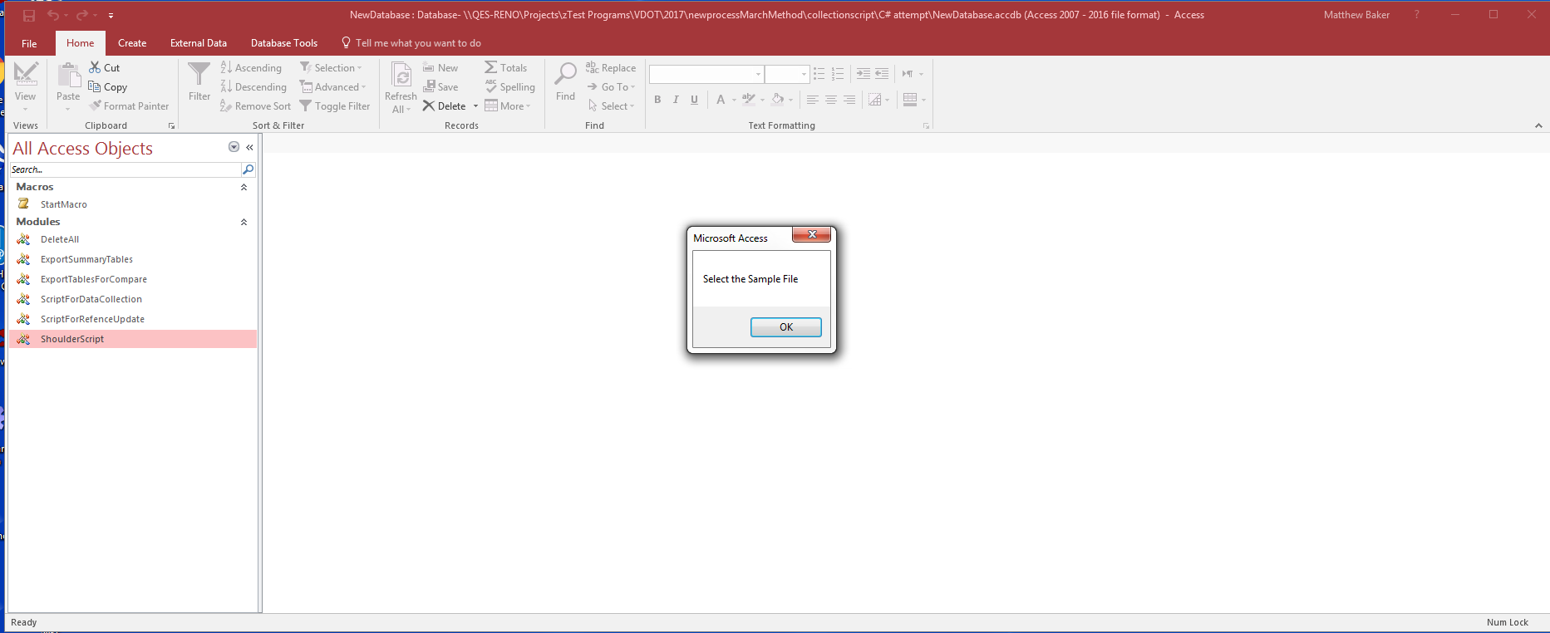

**STEP 6:** A file browser will open up. Choose the sample file and click “Open”. 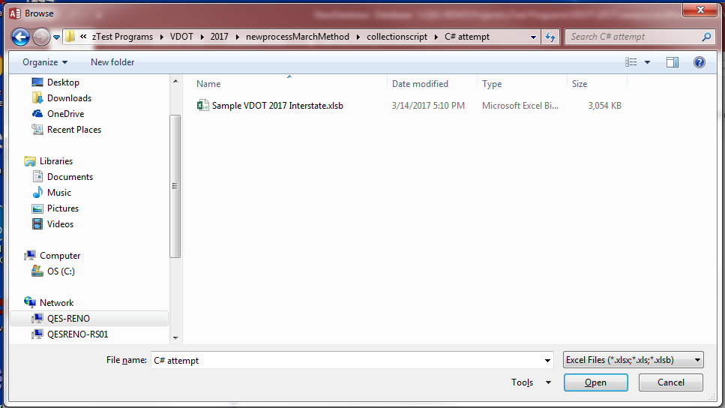

**STEP 7:** A box will prompt you to enter the number of QES databases are needed for the division. Enter the number of QES databases and click “OK”.

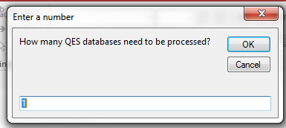

**STEP 8:** A prompt will ask you to select the first database. Click “OK”. 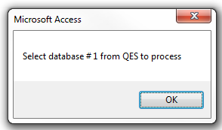

**STEP 9:** Choose the first database that needs to be processed and click “OK”. 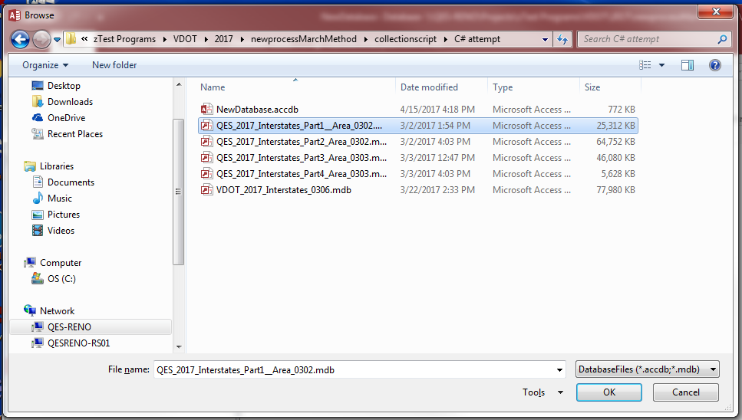

**STEP 10:** This prompt will appear multiple times throughout the processing. Click “Open” each time it pops up.

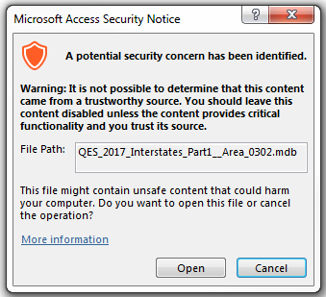

A progress bar will show up in the bottom right corner of the access window. 

**STEP 11:** If there are multiple databases, the program will loop from STEP 8 asking for the other databases. After the last database is processed, the program will ask you for the number of FWG databases used to process this district. Enter the number of FWG databases and click “OK”.

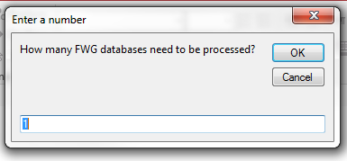

**STEP 12:** A prompt will ask you for the FWG database. Click “OK”. 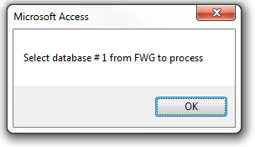

**STEP 13:** A file browser will open up. Choose the FWG database for the district and click “OK”. 

**STEP 14:** The security notice will pop up multiple times. Click “Open” each time this prompt is shown.

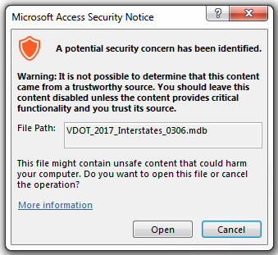

**Step 15:**  Once Access is done creating all the files, Access will close and Excel will start running scripts. Once the program reaches the scripts for QAResults, it will ask for a name for the division. The name will be placed in front of the titles on the graphs. Enter a name or leave it blank. CRCPQA and JRCPQA will also ask for the name to title the graphs in those files.

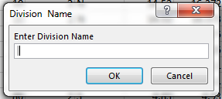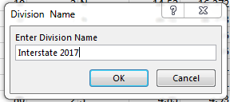

Examples shown below

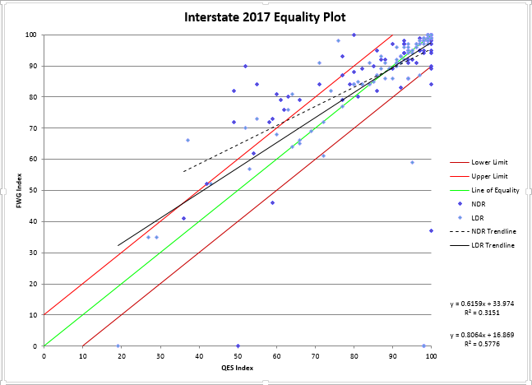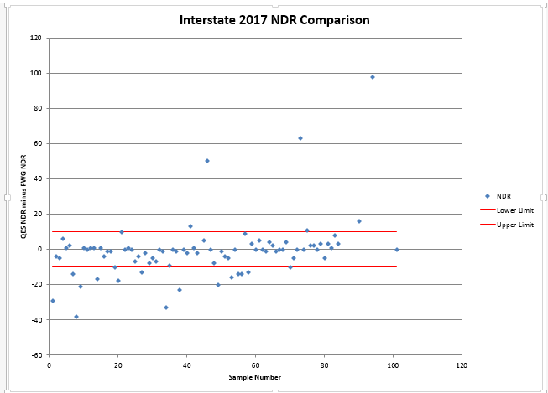

**STEP 16** : Once it reaches the Shoulder Comparison Script, a dialog box will pop up telling you that it will reorder the table. Click OK.

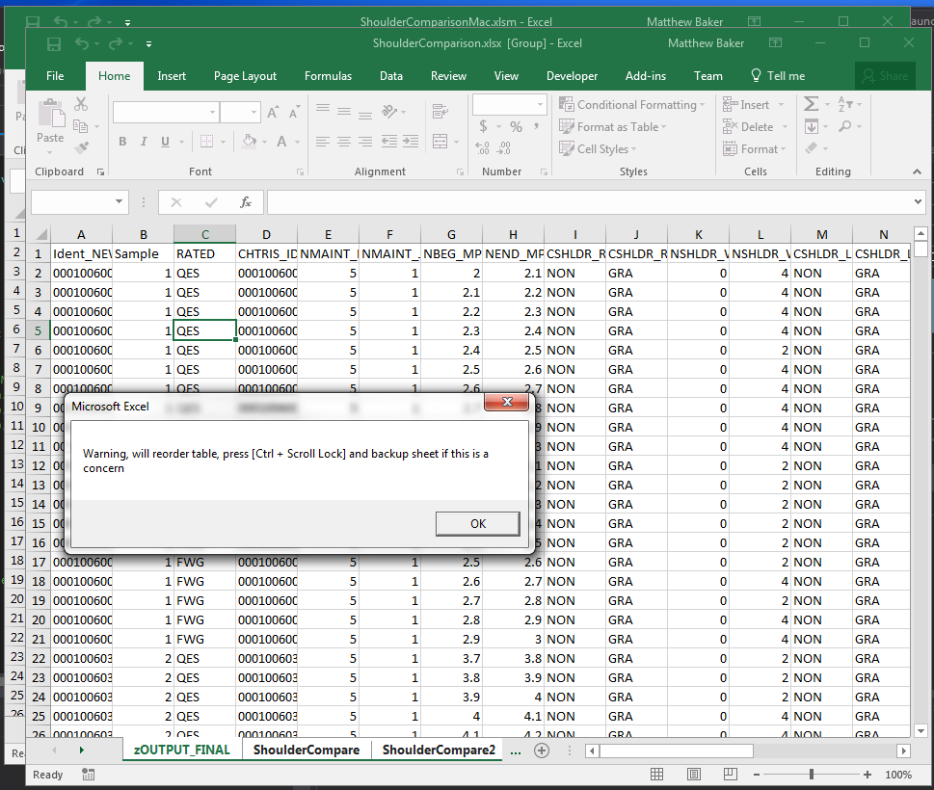

**STEP 17**: Once the Shoulder Comparison Script has finished, a dialog box will open telling you it is done. Click OK.

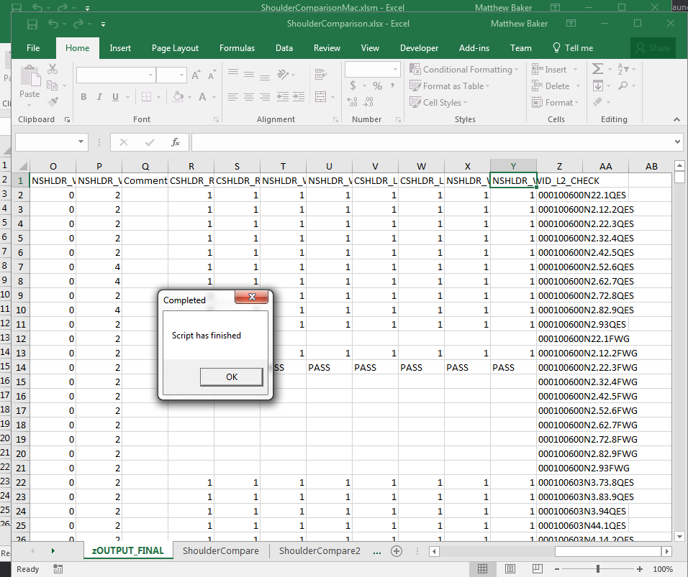

**STEP 18:** After the final Excel script is finished, the program will let you know that processing has been completed. Click “OK”.

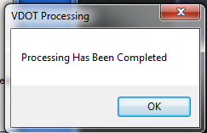

**STEP 19:** The excel files and the new access database with the information from processing are in the folder that was chosen at the beginning of the processing.

**What Happens When Reprocessing a District –**

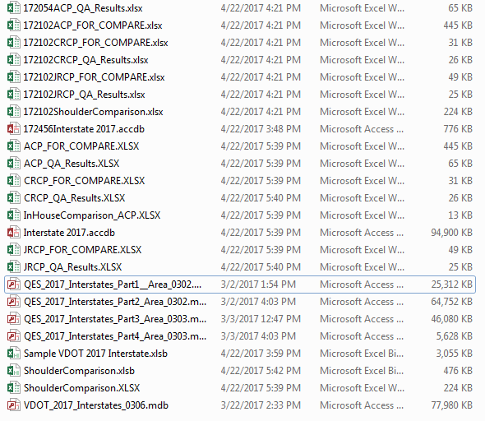

If there are old output files in the folder, they are renamed with the current time added to the beginning of the old file name. The time is in Hour Minute Seconds format. This prevents old data from being erased. If there is a database with the same name as the one you choose, the old database also has the time appended to the front of the old name.